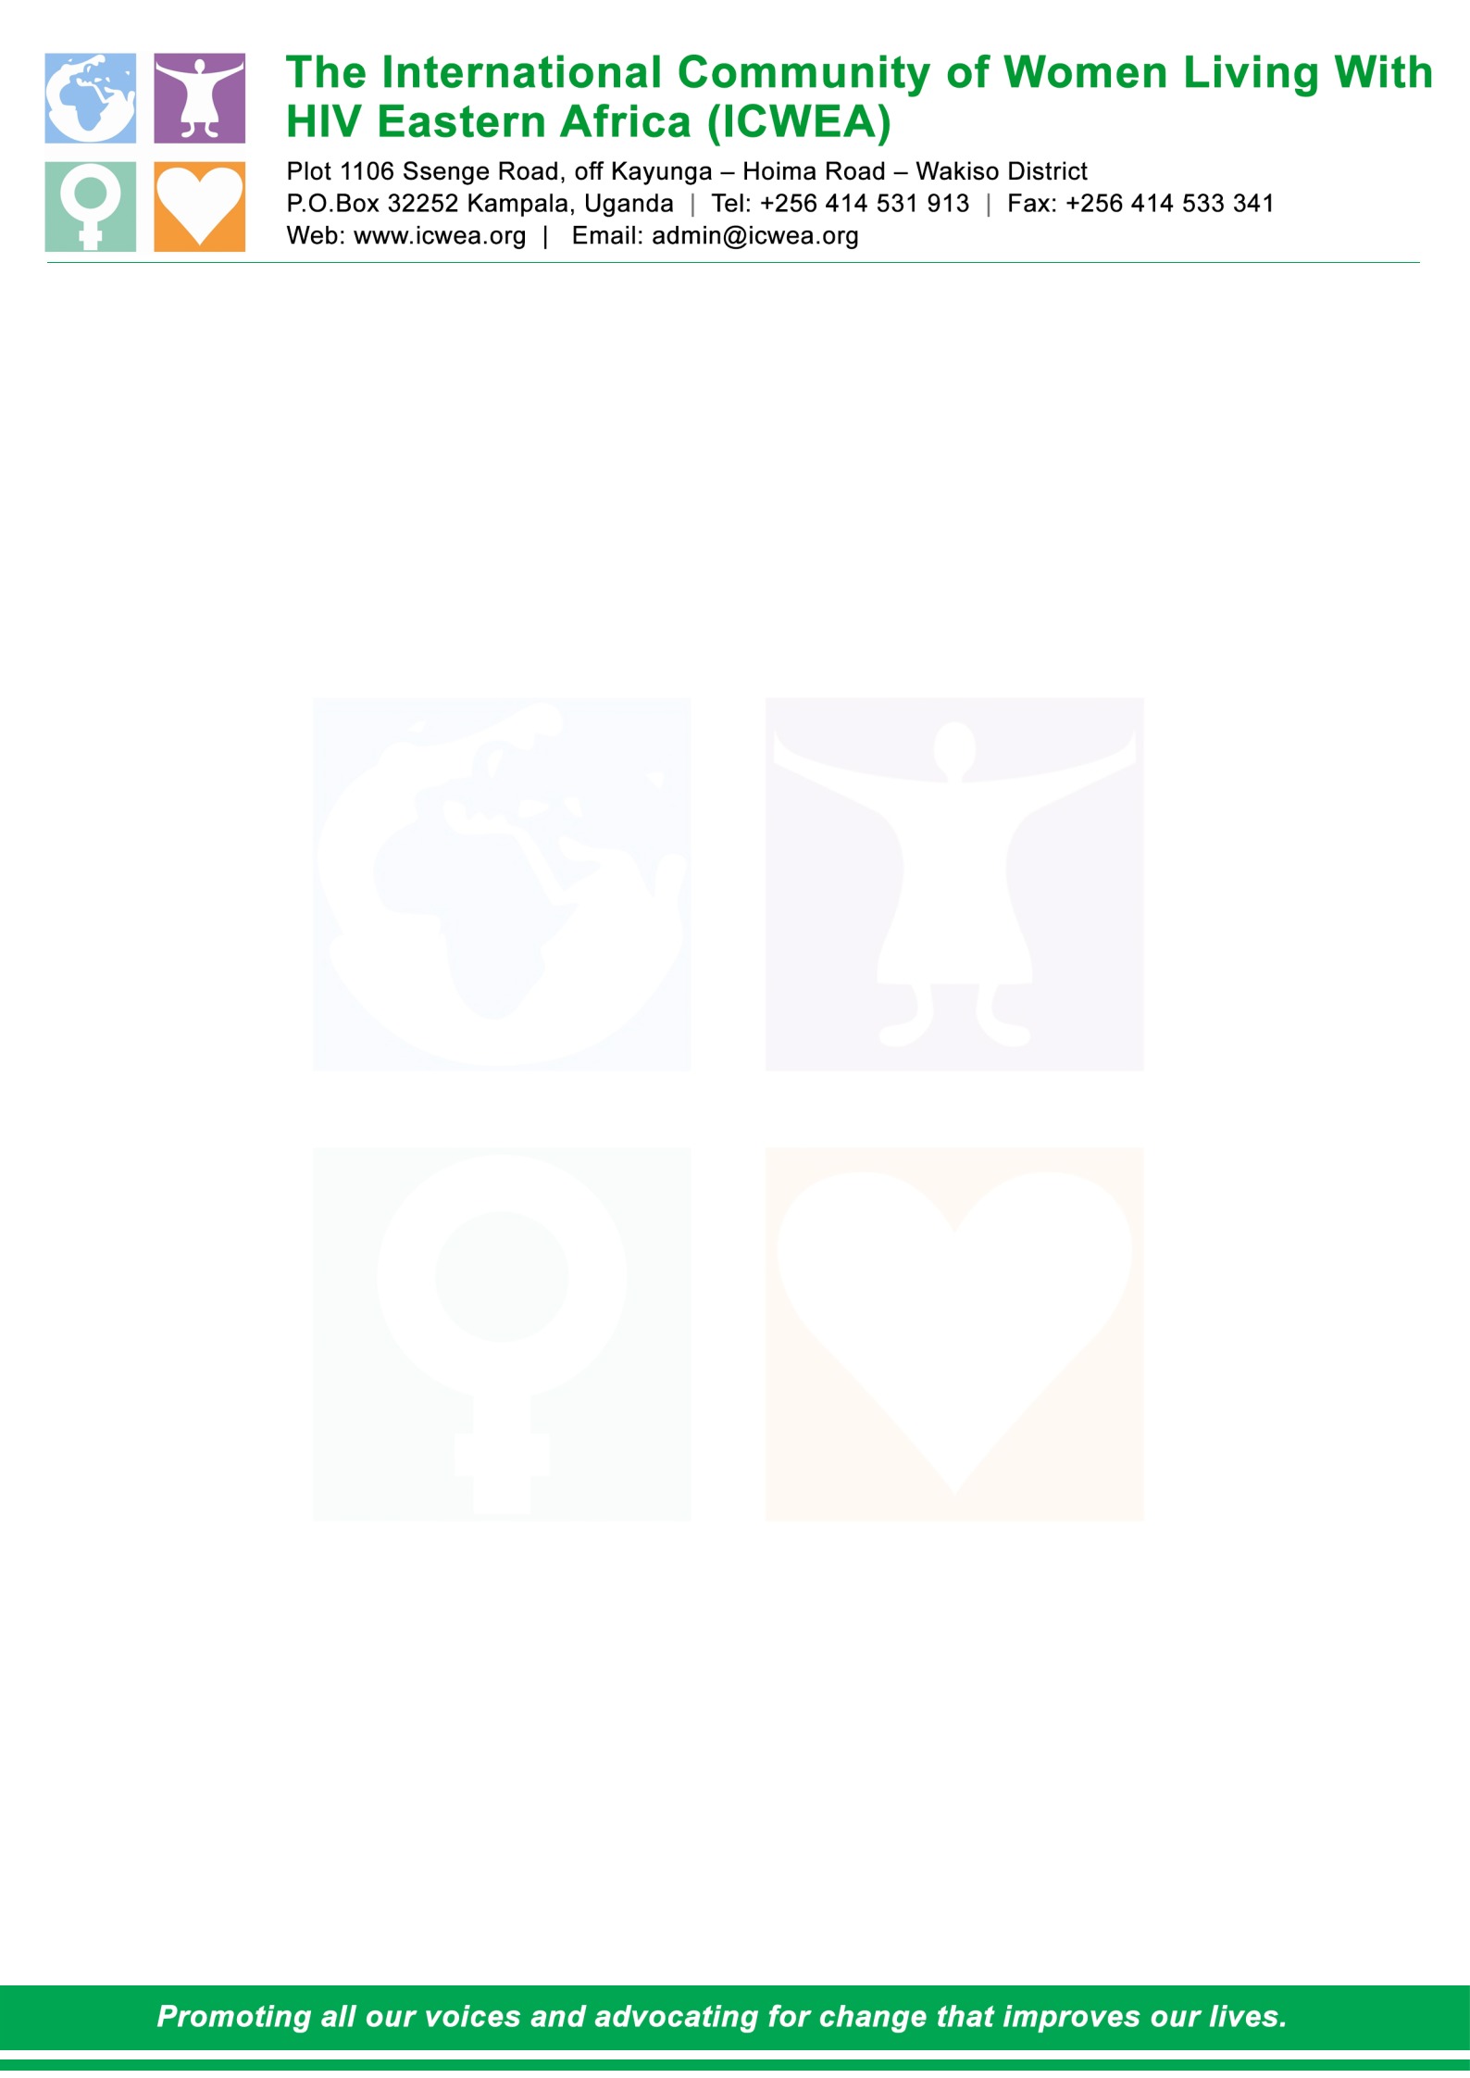

TERMS OF REFERENCE FOR CONDUCTING CONSULTATIONS TO INCLUDE GENDER RELATED ISSUES IN THE COMMUNITY SCORE CARD TOOLS

SEPTEMBER, 2021

Contents
1.0 Introduction 3
1.1 About ICWEA 3
1.2 Background to the Assignment 3
2.0 Purpose of the assignment 4
2.1 Specific objectives of the consultancy 4
2.2 Targeted districts: 4
2.3 The Consultations Target Audiences; 5
3.0 Scope of work 5
4. Deliverables 5
5. Reporting: 5
6. Professional expertise and qualifications: 6
7. Remuneration: 6
8. Commencement of work 6
9. Application procedure: 6
10. Submit Application Interested 6

1.0 Introduction

1.1 About ICWEA
The International Community of Women living with HIV Eastern Africa (ICWEA) is a network for and by women living with HIV. Founded in 2005, ICWEA exists to give visibility to women living with HIV through promoting collective voices to advocate for changes that improve our lives, stand up for our rights which are often violated, and influence positive policy improvements that support the wellbeing of women living with HIV. ICWEA believes that Gender inequalities and the limited access to Sexual Reproductive Health & Rights (SRHR) for women are at the heart of the HIV epidemic.

1.2 Background to the Assignment
International Community of Women Living with HIV Eastern Africa (ICWEA)with financial support from The AIDS Support Organization (TASO) / Global Fund (GF) is implementing a three-year project aimed at reducing human rights related barriers in accessing HIV/TB services at community level to improve treatment and retention in care.

One of the planned activities is the implementation of the Community Score Card (CSC) in 21 districts of Uganda. Gender plays an important role in the HIV epidemic and one of the key components of the score card is to ensure that gender is fully integrated fully.

ICWEA plans to implement a community Score card in 21 high HIV burden districts to monitor the quality of HIV/ TB related services provided. The community Score Card is a participatory social accountability tool designed and used to plan, monitor, and evaluate services. ICWEA believes that in a common collaboration between the rights holders and duty bearers, the provision of services can sustainably change for the better. The purpose of a Score card process is to improve the quality, efficiency and accountability of services at community level. The planned Community Score Card is a two-way and ongoing participatory process which seeks to strengthen the mutual understanding between service providers and service users to ensure collaborative action and overcome gaps. It will help to establish a feedback mechanism between service users and providers as well as track if HIV/ TB services and programmes in 21 districts are progressing well and compare performance of services across facilities.

Gender is used to describe the characteristics of women and men that are socially constructed (WHO 2016). People are born female or male, but learn to be girls and boys who grow into women and men. This learned behaviour make up gender identity and determines gender roles. Gender analysis on the other hand identifies analyses and informs action to address inequalities that arise from the different roles of women and men or un equal power relations between them and the consequences of these inequalities on their lives, their health and well-being. ICWEA plans to improve the existing Community Score card tools that was developed and used during the implementation of NFM 11 work (2018-2020) and make it more gender inclusive. Gender equality and social inclusion addresses improving access to livelihood assets and services for all. It supports more inclusive policies and mindsets and increases the voice and influence of all including of women, the poor and excluded.

In this case exclusion happens on the basis of identity. These identities constitute what is described in Uganda’s policies as “vulnerable groups.” They include orphans and other vulnerable children (OVCs), persons with disabilities (PWDs), unemployed youth, displaced persons, marginalized women, older persons, and ethnic minorities (MGLSD, 2016). PWDs constitute about 18% of the population (UNHS, 2010). About 46% of girls are married below the age of 18 (UNICEF, 2015), while youth unemployment stands at 18% (MGLSD, 2016). Despite vulnerabilities caused by disability and old age, only 5% of the population have access to government social safety nets (World Bank, 2016). The above attributes lead to exclusion of these categories of people from services and economic opportunities. For instance, although women constitute 84% of agricultural labour force, they own only 27% of registered land (NPA, 2013). Women are disproportionately represented in unpaid care work – spending over three hours a day on housework compared to less than one hour spent by men (Action Aid, 2014). This and the low number of women in technical and professional jobs limits their incomes. Men earn more than twice (USD 2,535) as much as their female counterparts (USD 1,008) annually (WEF, 2016). Other forms of exclusion from markets include: exclusion of youth, due to limited skills and experience, exclusion of PWDs due to limited labour capacity, and exclusion of LGBTI people due to low social tolerance for their sexual orientation among others.

While rights determine access to resources and authority, to claim these rights people need access to resources, power, and knowledge. Unequal social relations result in some individuals and groups being more able to claim rights than others. For example, the LGBTI community highlighted its inability to exercise their rights and citizenship due to legalized homophobia. Refugees, for their part, are also limited from claiming their economic rights and citizenship privileges. Women continue to suffer GBV and are constrained in obtaining justice. Excluded groups have apathy towards participating in governance processes because of the perceived lack of direct reward for their participation. In addition, adolescent girls account for a significant proportion of maternal deaths in Uganda annually. Some drivers of these reproductive health challenges are rooted in gender and social norms that encourage large families, early child marriage, teenage pregnancy, and limited access to youth-friendly reproductive health services, as further discussed. There is therefore need for inclusion of gender related questions in the score card to ensure the gender gaps are addressed.

2.0 Purpose of the assignment
The objective of this work is to ensure that key local stakeholders are consulted on what they think are the key gender issues that need to be included into the score card tool to ensure that more gender inclusive and responsive interventions are designed in future that aims at enhancing access to HIV/TB and Malaria related services.

2.1 Specific objectives of the consultancy
The scorecard is aimed at three diseases and conditions (TB, Malaria, HIV/AIDS), gender equality processes, RMNCHA and human rights entitlements in health service delivery in order to:
- Adapt existing scorecard tools to include a minimum set of indicators for monitoring the 3 diseases and their conditions, gender equality processes, RMNCHA and human rights entitlements in health service delivery.

- Generate and compile community level views/feedback on the quality of HIV, TB, Malaria and RMNCHA service delivery.

2.2 Targeted districts:
Bundibugyo, Kasese, Kabarore, Isingiro, Kisoro, Ntoroko, Mbarara, Ntungamo, Rubanda, Rubirizi, Buikwe, Kalangala, Kampala, Kayunga, Nakaseke, Nakasongola, Buliisa, Gulu, Hoima, Kiboga and Kyankwanzi.

2.3 The Consultations Target Audiences;
DHO, DHE, Focal persons for TB, Malaria, HIV, DCDO, DEO, CAO, Chairperson LC V) 4 Health facility in charges, CFPU, probation, Cultural & religious leaders, IPs, PLHIV, KPs, PWDs, Youths, District based CSO’s.
Description of the meeting: This meeting will involve holding consultative meetings in the 21 districts to ascertain what Gender related issues should be involved in the CSC.
The total number of participants in these consultative meetings will be 50 per meeting. Each consultative meeting will last for 2 days about Gender but should also look at the content of the score card. The meeting will also look at the current CSC tool that was used in NFM2 CSC.

3.0 Scope of work
The assignment shall be carried out in 21 LGs across the country and will involve:
The consultant will provide support in the following areas;
- Review of the available community-based scorecard tools to highlight key gender gaps for completeness to include HIV, TB, Malaria, gender equality processes, human rights entitlements and RMNCHA
- Development of the Assessment tool
- Present the Assessment tool to national Gender Working Group for approval.
- Training of a team of at least 5 experts to support consultations in districts
- Develop training materials and train data collectors to administer the scorecard tools, supervise data collection, cleaning, entry and analysis at both Local and national levels.
- Guide district level dissemination of preliminary findings. The main target population for generation of community level views shall be beneficiary groups such as networks/representatives of civil society organizations (CSOs), networks of people living with the diseases and conditions (malaria, TB and HIV/AIDS), human rights/networks of key populations, gender equality representatives, women and girls including survivors of GBV.
- The views shall be generated through participatory rapid surveys using a well-developed gender analysis tool. Some of the main avenues for validation and consensus attainment for key scorecard indicators/minimum set of standards, generated community views and dissemination of findings shall include among others; dialogues with community key resource persons, local government authorities, health facility level meetings and District level meetings.
- Present the gender assessment tools to the National Gender working group for review & approval before training and consultations and then present the draft report before the national consensus meeting;
- Integration of outcomes from the field and writing one report
- Facilitate the national level validation meeting

4. Deliverables
- An inception report with clear deadlines and assessment tools for consultations
- Revised scorecard with indicators on three diseases (HIV, TB and Malaria), gender equality processes and human rights entitlements clearly indicated.

5. Reporting:
The work will be carried out with close coordinating of the Executive Director and the Project Officer coordinator.

6. Professional expertise and qualifications:
The Consultant will be selected on the basis of their proven experience, qualifications and ability to deliver good quality work in a timely and efficient manner.

The minimum qualification include;
- A Master’s degree in Gender studies /social sciences or any other relevant degree.
- Proven record of conducting gender-based research and programming, supporting NGOs with gender analysis on particular projects.

7. Remuneration:
The remuneration for the assignment will be determined and agreed upon during the first meeting with the successful candidate. 50% payment of the quoted amount will be paid after the signing of the contract and upon submission on the inception report. 50% will be paid upon the submission of the Final copy of the gender consultation report.
All payments are subject to the statutory deductions as per the laws of Uganda.
8. Commencement of work:
The Consultant shall begin work immediately after signing the contract with ICWEA, and the Consultant shall deliver in good faith the best possible quality of work for the satisfaction of the contract.

9. Application procedure:
Interested individual consultants must submit the following information not later than Friday 17th September 2021. Include:-
- The Relevant past experience in similar tasks, and at least 3 references.
- Expression of interest explaining why you are the most suitable person for the task, and providing a Brief methodology on how you will approach and conduct the task.
- A financial proposal broken down in line with the deliverables.

10. Submit Application Interested
Due to COVID-19, interested applicants can submit their complete proposal either “electronically or hand deliver to ICWEA offices with all the required documents under the subject matter: “Inclusion of Gender Related Issues in the Scorecard”

Physical Address:
` Plot 1106, Ssenge - Kawanda Road, Off Kayunga - Kampala - Hoima Road,
P.O. Box 32252, Kampala, Uganda
Tel. +256 414531913
OR E-Mail: admin@icwea.org copy in lmworeko@icwea.org

The deadline for submission of proposals is 17th September, 2021 not later than 5.00pm
Only shortlisted candidates will be contacted

ICWEA will be responsible for mobilizing and convening a meeting with the Gender National Working Group

