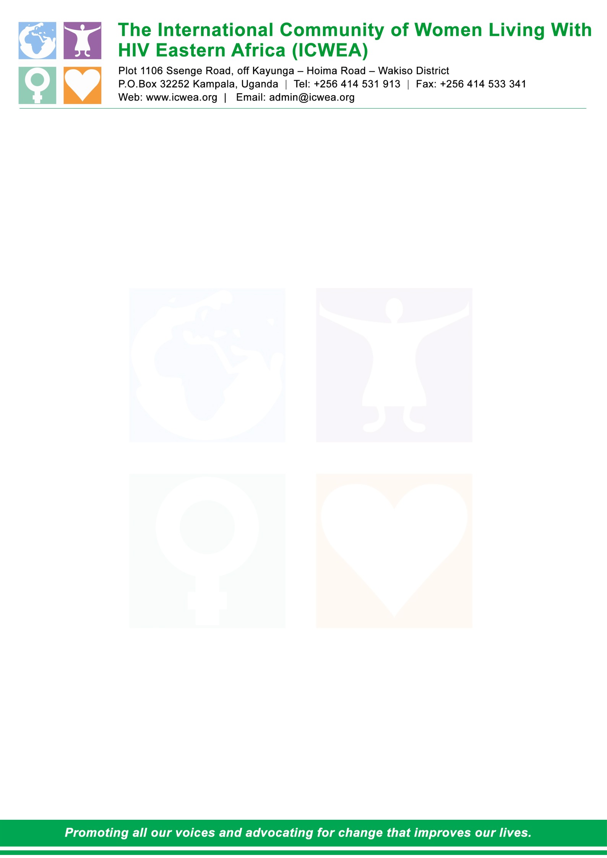

TERMS OF REFERENCE FOR CONSULTANCY TO DEVELOP AND IMPLEMENT A COMMUNITY SCORE CARD (CSC)

SEPTEMBER, 2021

Contents
1.0 Introduction 3
1.1 About ICWEA 3
1.2 Background to the Assignment 3
2.0 Introduction 3
3.0 Purpose of the consultancy 4
3,1 Specific objectives of the consultancy 4
4.0 Scope of work 4
4.1 Specific tasks of the technical lead person 5
5.O Methodology 5
6.0 Expected Deliverable 6
7.0 Terms of Payment 6
8.0 Time frames/work schedules 6
9.0 Qualifications, Experience, and Skills: 6
10.0 Local services, personnel, and facilities to be provided by the Procuring organization: 6
11.0 Management and Supervision of the exercise/Institutional arrangement 7
12.0 How to Apply 7

Introduction

1.1 About ICWEA
The International Community of Women living with HIV Eastern Africa (ICWEA) is a network for and by women living with HIV. Founded in 2005, ICWEA exists to give visibility to women living with HIV through promoting collective voices to advocate for changes that improve our lives, stand up for our rights which are often violated, and influence positive policy improvements that support the wellbeing of women living with HIV. ICWEA believes that Gender inequalities and the limited access to Sexual Reproductive Health & Rights (SRHR) for women are at the heart of the HIV epidemic.

1.2 Background to the Assignment
International Community of Women Living with HIV Eastern Africa (ICWEA)with financial support from The AIDS Support Organization (TASO) / Global Fund (GF) is implementing a three-year project aimed at reducing human rights related barriers in accessing HIV/TB services at community level to improve treatment and retention in care.

One of the planned activities is the implementation of the Community Score Card (CSC) in 21 districts of Uganda. Gender plays an important role in the HIV epidemic and one of the key components of the score card is to ensure that gender is fully integrated fully.

ICWEA plans to implement a community Score card in 21 high HIV burden districts to monitor the quality of HIV/ TB related services provided. The community Score Card is a participatory social accountability tool designed and used to plan, monitor, and evaluate services. ICWEA believes that in a common collaboration between the rights holders and duty bearers, the provision of services can sustainably change for the better. The purpose of a Score card process is to improve the quality, efficiency and accountability of services at community level. The planned Community Score Card is a two-way and ongoing participatory process which seeks to strengthen the mutual understanding between service providers and service users to ensure collaborative action and overcome gaps. It will help to establish a feedback mechanism between service users and providers as well as track if HIV/ TB services and programmes in 21 districts are progressing well and compare performance of services across facilities.

Introduction
The Government of Uganda approved the Comprehensive National Development Planning Framework (CNDPF) that operationalizes the 30-year development plan (Vision 2040). It recognizes that good health is instrumental for socioeconomic transformation to achieve middle level income status. The vision proposes a paradigm shift from facility-based to community health systems and prioritizes preventive over curative health services and Universal Health Coverage (UHC). UHC addresses dimensions of equity, financial risk protection, gender and human rights in access to health care. These are the same beliefs of a resilient and sustainable health system echoed in global health. The country continues to build a health system cognizant of its inheritance by leveraging on efficiencies in private sector and embracing community level responses and systems. As the Government of Uganda implements the Comprehensive National Development Planning Framework, there is need to receive feedback from service recipients on the quality and comprehensiveness of health service delivery among others.

As part of the dual track financing, the GFTAM provided funds to the AIDS Support Organization (TASO) Uganda Ltd (the non-public sector Principal Recipient (PR)) to develop/adapt existing scorecards as part of the priority interventions to strengthen community-based monitoring for accountability. TASO U Ltd contracted UGANET (Sub recipient) and ICWEA together with HRAPF as sub-sub recipients to implement part of NFM3.

ICWEA is implementing a 3-year Global Fund NFM3 project aimed at reducing human rights related barriers in accessing and utilization of HIV/TB services to improve treatment outcomes and retention in care. As part of the program, ICWEA is scheduled to administer a scorecard in 21 districts of Uganda with the aim of generating evidence (baseline) on the quality of HIV/TB service. ICWEA intends to engage services of a consultant to guide implementation of the scorecard in the 21 districts.

A community scorecard is one sure way of assessing how well an intervention is understood and embraced by beneficiary communities. The tool is used for soliciting views using participatory appraisal approaches from beneficiary communities on how well interventions respond to their needs, and it is also meant to strengthen the culture of observing a minimum set of standards for service delivery.

Purpose of the consultancy
The scorecard is aimed at building capacities of district level network of people living with or affected by the 3 diseases on the use of community score and report card (CSRC) to track, document and report on availability, timeliness, accessibility and quality of HIV, TB, Malaria and RMNCHA services. It also aims at improving social accountability.

3,1 Specific objectives of the consultancy
The scorecard is aimed at three diseases and conditions (TB, Malaria, HIV/AIDS), gender equality processes, RMNCHA and human rights entitlements in health service delivery in order to:
- Adapt existing scorecard tools to include a minimum set of indicators for monitoring the 3 diseases and their conditions, gender equality processes, RMNCHA and human rights entitlements in health service delivery.
- Generate and compile community level views/feedback on the quality of HIV, TB, Malaria and RMNCHA service delivery.

Scope of work
- The assignment shall be carried out in 21 LGs across the country and will involve:-
- Review of the available community-based scorecard tools for completeness to include HIV, TB, Malaria, gender equality processes, human rights entitlements and RMNCHA – present the tool to national taskforce for approval.
- Develop training materials and train data collectors to administer the scorecard tools, supervise data collection, cleaning, entry and analysis at both Local and national levels.
- Guide district level dissemination of preliminary findings. The main target population for generation of community level views shall be beneficiary groups such as networks/representatives of civil society organizations (CSOs), networks of people living with the diseases and conditions (malaria, TB and HIV/AIDS), human rights/networks of key populations, gender equality representatives, women and girls including survivors of GBV. The views shall be generated through participatory rapid surveys using a well-developed community scorecard tool.
- Some of the main avenues for validation and consensus attainment for key scorecard indicators/minimum set of standards, generated community views and dissemination of findings shall include among others; dialogues with community key resource persons, local government authorities, health facility level meetings and District level meetings.
- At national level; disease specific annual review meetings such as to the Joint AIDS Review (JAR), Health Review Mission and the TB annual review meetings may be targeted.

4.1 Specific tasks of the technical lead person
The consultant will specifically do the following;
- The consultant will develop an orientation guide for the following target groups
  - The implementation team at ICWEA.
  - The district leaders to support scorecard implementation.
  - Community representatives to be oriented from the selected 21 focus districts
- Guide orientation of data collectors and supervise data collection process.
- Develop data collection tools Support teams to administer the scorecard checklist/tool in 21 districts (targeting 4 health facilities per district)
- Support data analysis and report writing. The consultant will be expected to produce a comprehensive and abridged version of the reportSupport national and district teams to disseminate data at district and national level

5.O Methodology

- The key steps shall include but not be limited to:-
- Conducting in-depth desk literature reviews and content analysis of the existing community-based scorecard tools and reports with focus on the three diseases and conditions (Malaria, TB and HIV/AIDS), Gender responsive programming, human rights entitlements and RMNCHA,
- Holding consultative and consensus building meetings with key stakeholders including; Development Partners, Ministry of Health, Uganda AIDS Commission (UAC) and representatives of CSO Networks, primary data collection through participatory rapid surveys in 21 districts using a well-developed community scorecard tool among other methods to generate information to meet the objectives of the assignment.
- Some of the main avenues for validation and consensus attainment for key scorecard indicators/minimum set of standards, generated community views and dissemination of findings shall include among others; dialogues with community key resource persons, local government authorities, health facility level meetings and District level meetings.
- At national level; disease specific annual review meetings such as to the Joint AIDS Review (JAR), Health Review Mission and the TB annual review meetings may be targeted.
- The consultant is expected to enrich with justification this methodology and provide details of how the assignment will be executed as part of the inception report.

6.0 Expected Deliverable
- Training package for national level facilitators
- Training package for district level scorecard facilitators
- Score sheets for all health facilities in the 21 Districts.
- Summaries for each district – before final analysis
- Final scorecard report containing all 21 districts

7.0 Terms of Payment
Payment of the consultant shall be in 3 instalments of: 40% at approval of the inception report, 30% at presentation of the first draft of the report and 30% after producing the validated and approved report by the National Taskforce. This is aimed at providing enough funds to the enable field work and data entry in order to have a timely submission of the deliverables. Note that ICWEA shall be responsible for the field work costs and other reimbursable cost.

8.0 Time frames/work schedules
The assignment is expected to be undertaken within a period of 14 working days spread after signing of the contract.

9.0 Qualifications, Experience, and Skills:
- An advanced degree in a relevant discipline (e.g., as statistics, Quantitative Economics, Demography or a related field),
- 5+ years’ experience in a relevant field, such Gender & Social Inclusion, HIV&AIDS programming, Public Health and or a related field.
- Experience in running TASO/ Global Fund related studies / evaluations
- Experience in research related to Gender equality Programmes and HIV& AIDs intervention
- Knowledge of existing research and data analysis tools
- Strong quantitative and qualitative data analysis and reporting skills.

10.0 Local services, personnel, and facilities to be provided by the Procuring organization:
ICWEA shall offer space for consultative meetings to the consultant(s) during the assignment, contact staff who will guide and supervise the consultant(s) during the assignment (details will be agreed upon during the inception meeting). The National Taskforce on the score card will contribute towards this process through formal communication to provide the required support to the technical lead person where the need arises.

11.0 Management and Supervision of the exercise/Institutional arrangement
The overall technical supervision shall be the Project Coordinator at ICWEA secretariat. The Project Coordinator will work with CSC National Taskforce to support the consultant(s) of the assignment in providing formal communications, convening key stakeholder consensus and consultative building meetings. The CSC taskforce will provide the technical guidance to the deliverables and outputs of the assignment to the consultant. ICWEA will provide required financial and administrative support and guidance towards effective execution of the assignment.

12.0 How to Apply
Qualified candidates interested in the position are expected to provide the following:
- A proposal responding to the Terms of Reference. Proposals should include:
- Short overview of how the candidate meets the qualifications, experience and skills requirements (no more than one page).
- Description of proposed approach and methodology.
- Initial work plan based on methodology outlined.
- Financial proposal should be submitted as separate documents, including: daily-rate, projected travel and in-country accommodation and subsistence costs. Holding tax must also be included where relevant. Payment methods and milestones should also be included.
- An indication of availability.
- Company profile or CV including a minimum of 3 references

Submit your complete proposal in both “electronic and hard copy formats” to ICWEA indicating “Conduct Community Score card” as the subject/envelope label.
Submit to: Plot 1106, Ssenge - Kawanda Road, Off Kayunga - Kampala - Hoima Road,
P.O. Box 32252, Kampala, Uganda
Tel. +256 414531913
E-Mail: admin@icwea.org
Mobile: +256392947313

N.B: Applicants shall submit both electronic and hard copy formats

The deadline for submission of proposals is 20th Sept, 2021 not later than 5.00pm

Bundibugyo, Kasese, Kabarore, Isingiro, Kisoro, Ntoroko, Mbarara, Ntungamo, Rubanda, Rubirizi, Buikwe, Kalangala, Kampala, Kayunga, Nakaseke, Nakasongola, Buliisa, Gulu, Hoima, Kiboga and Kyankwanzi
ICWEA will be responsible for forming and managing the national taskforce

